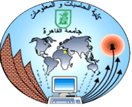
Cairo University
Faculty of Computers and Information

CS251
Software Engineering I
Funny learning☺
Software Design
Team Names
Marwa Ashraf
Hanaa Salah
Renad Salem
Zeinab Ibrahim
Month & Year
Contents
Team 3
Document Purpose and Audience 3
System Models 3
I. Class diagrams 3
II. Sequence diagrams 6
Class - Sequence Usage Table 10
Ownership Report 11

Team
ID | Name | Email | Mobile
20140260 | Marwa Ashraf | merootreka212@gmail.com | 01140095542
20140132 | Zeinab Ibrahim | zeezee3215@gmail.com | 01025898706
20140129 | Renad Salem | renadsalem97shr@gmail.com | 01000167891
20140310 | Hanaa Salah | Hanasalah1512@gmail.com | 01122909949

Document Purpose and Audience
-This document is about our software project .
-Document contain details about the design of the system (class diagrams , sequence diagrams,……. )

System Models

I-Class diagrams

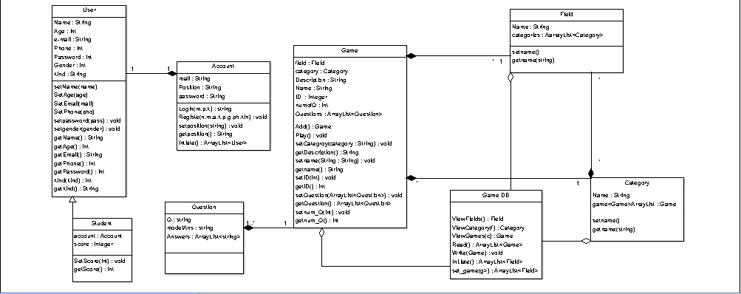

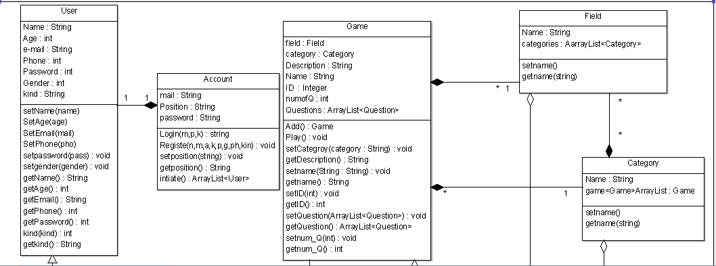
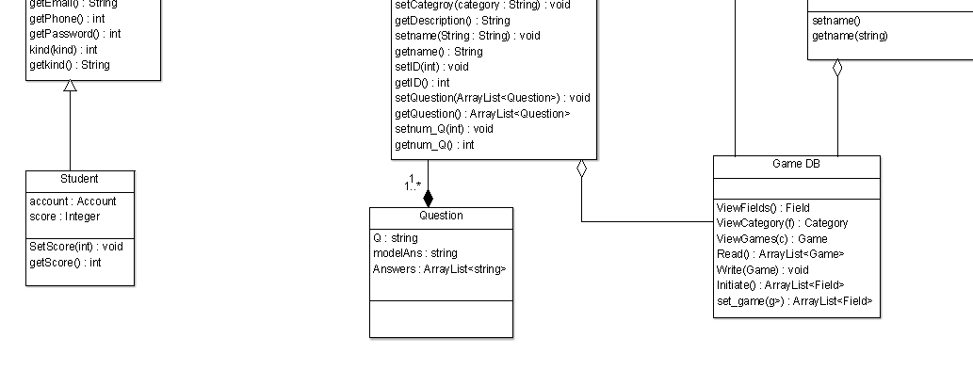

Class ID | Class Name | Description & Responsibility
0 | User | This class is about user data like user’s name , user’s ID ,….. and we can set and get the data of user using this class
1 | Account | This class is used to login as an existing account , create new accounts for new users ,set and get the user’s position
2 | Student | It’s a child class of the parent user it includes all attributes and functions exist in user class in addition to having the students’ scores and method to set score and returning it when we need
3 | Question | It contains game’s questions , answers and its model answer
4 | Field | It contains list of fields and we can choose fields using it
5 | Category | It contains list of categories of games for each field and we can choose category from
6 | Game | It contains all data of each game like game ID , game description , …. , it has all setters and getters for games’ data and it has also methods of playing game and adding new game
7 | GameDb | It saves all data for fields , categories , games , we can use this class to view fields , categories , games or to add new game

II. Sequence diagrams
1-Registration
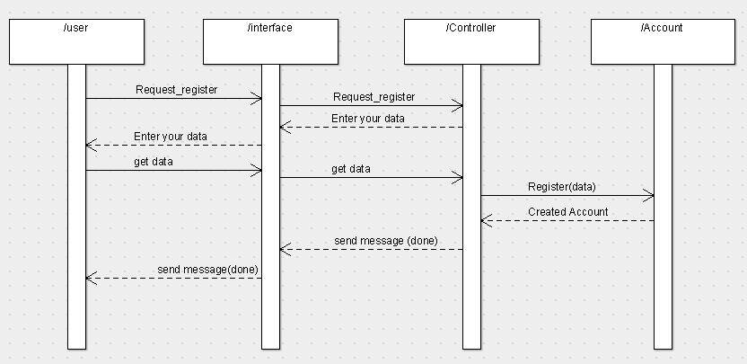
2-Login
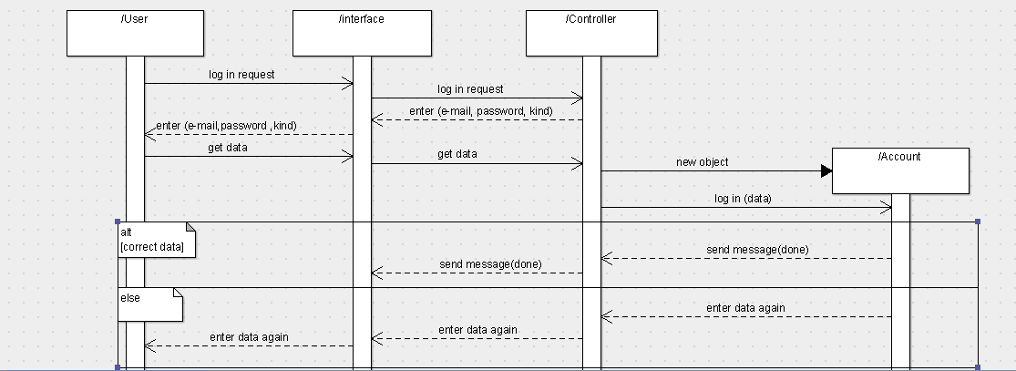
3-Play game

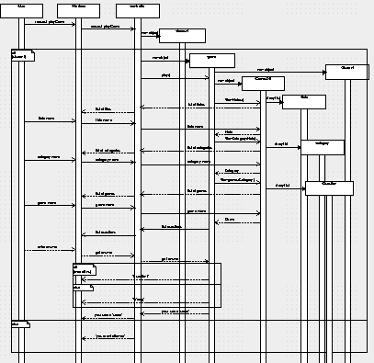
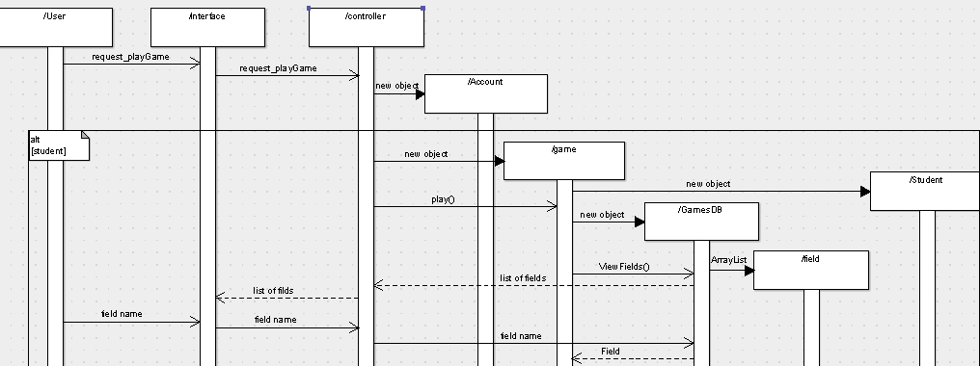
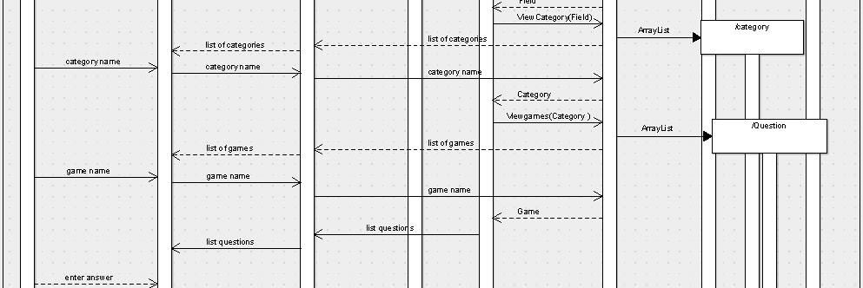
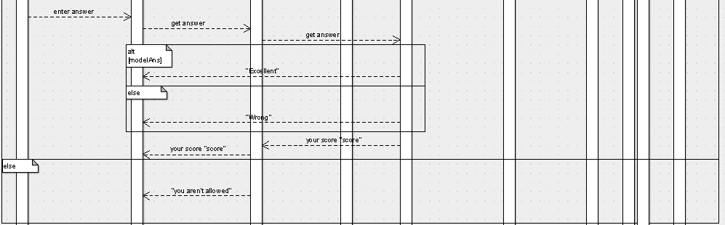
4-Add game
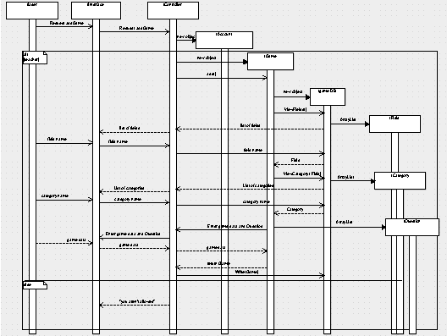
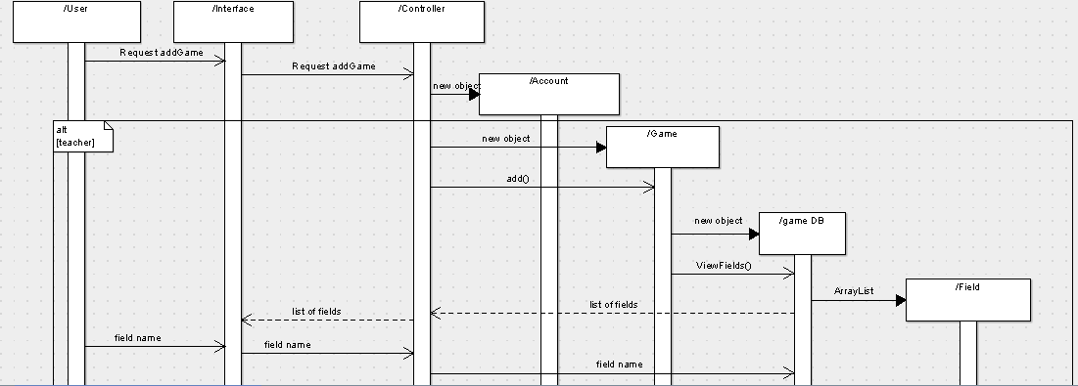
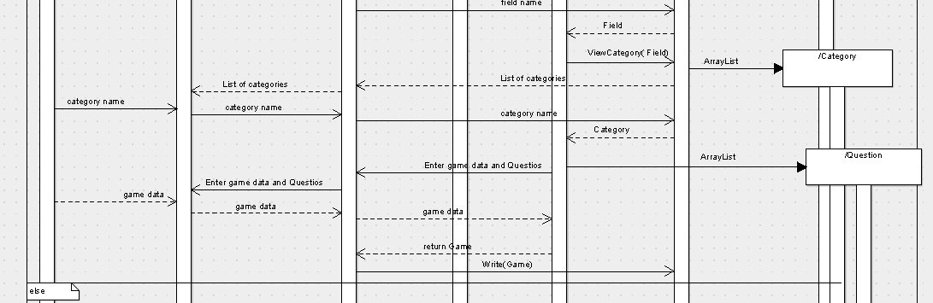
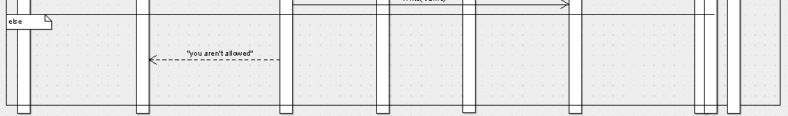

Class - Sequence Usage Table
Class Name | Sequence Diagrams | Overall used methods
User | 1,2,3,4 | Set and Get for all attributes and checking for correctness
Student | 3 | Setting and getting score
Account | 1,2 | Login , registration
Game | 3,4 | Setting game data , Playing game , adding game
Field | 3,4
Category | 3,4
Game DB | 3,4 | View fields(),ViewCategory( field name),View game(category name),Write(Game)
Question | 3,4

Ownership Report
Item | Owners

